Figure 1:
Scatterplot of Body Fat Percent by Waist Size Figure 2: Histogram of the Residuals
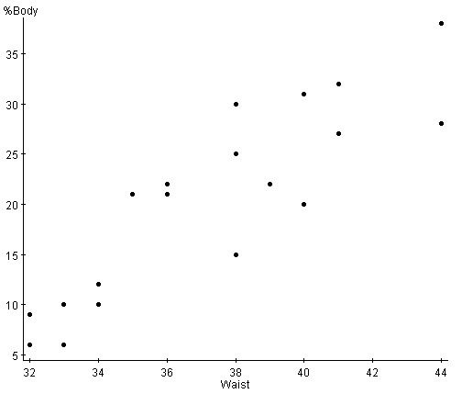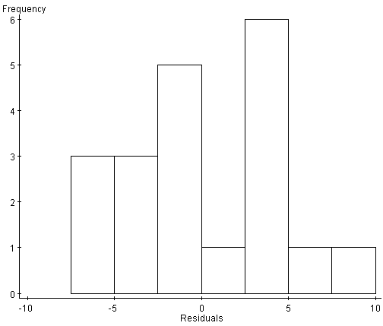

Figure 3:
Scatterplot of Residuals vs Waist Size Figure 4: QQ plot of the residuals
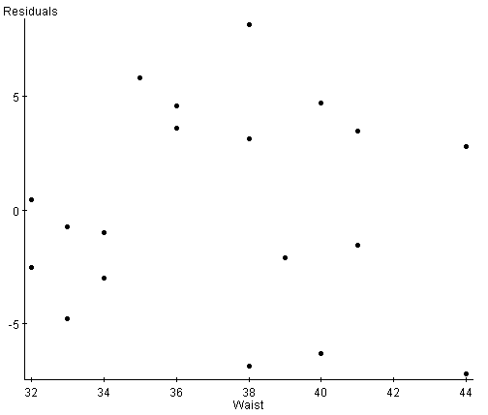 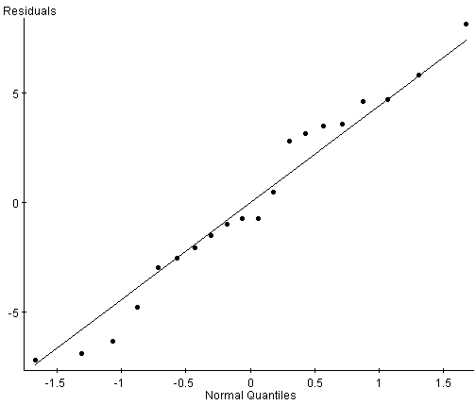\

Regression Example: Measuring body fat can be tedious and expensive. The “standard reference” measurement is by dual-energy X-ray absorptiometry (DXEA), which involves two low dose X-ray generators and takes 10 to 20 minutes. How close can we get to a useable prediction of body fat from easily measurable variables such as height, weight, or waist size?

Simple Linear Regression Output

Simple linear regression results:
Dependent Variable: %Body
Independent Variable: Waist
Sample size: 20
R (correlation coefficient) =
R-sq = 0.7865287
Estimate of error standard deviation: 4.5397
Parameter estimates:
Parameter | Estimate | Std. Err. | DF | T-Stat | P-Value
Intercept | -62.55732 | 10.157673 | 18 | -6.1586275 | <0.0001
Slope | 2.2215202 | 0.27278873 | 18 | 8.143738 | <0.0001
Analysis of variance table for regression model:
Source | DF | SS | MS | F-stat | P-value
Model | 1 | 1366.7903 | 1366.7903 | 66.32047 | <0.0001
Error | 18 | 370.95975 | 20.608875
Total | 19 | 1737.75

1. What four conditions should you check to determine if fitting a linear model is
appropriate for this data set? Check these conditions.

Textbook page 566

- The mean of the probability distribution of errors is 0. – True if using least squares method to determine the line of best fit.

- The values of the errors associated with any two observed values of y are independent. – check design

- The variance of the probability distribution of errors is constant for all settings of x. Verified: The scatterplot of the residuals vs the waist size shows no pattern which indicates this assumption is met.

- The probability distribution of the errors is normally distributed. Verified by using
the QQ plot of the residuals which shows that the residuals follow a linear pattern in the QQ plot indicating normally assumption is met.

2. Write the least squares equation for the data. Use variable names.

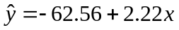

Where is predicted percent body fat and x is waist size in inches.

3. Interpret the meaning of the slope value in the context of the question.

For every one additional inch increase in waist size, percent body fat is estimated to increase by 2.22%.

4. Use your equation to predict the body fat% on a person with a waist size of 38in.

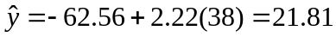
The predicted body fat percentage for someone with a waist size of 38” is 21.81%.

Extension Question: Suppose a subject with a waist size of 38” has an actual body fat % of 23%, find the residual for this observation.
Residual = actual – predicted value = 23-21.81= 1.19.
The prediction was an underestimate

5. What is the value of the correlation coefficient? Interpret its meaning in context.

r = .89 There is a strong positive linear association between waist size and percent body fat.

6. Explain what the r² value means in this example.

r^2 = .7865 78.65% of the variation in body fat percentage is explained by the least squares regression of body fat onto waist size.

7. Test the null hypothesis of no relationship against the directional alternative that the
percentage of body fat increases with waist size. Let α = .10

Ho: B₁=0 vs Ha: B₁ >0
Test Statistic = 8.14
Cutoff at α=.10 with df = 18 is 1.33
As test statistic exceeds the cutoff we reject the Ho.
There is evidence that as waist size increases, body fat percent also increases.

8. Construct a 95% confidence interval for the slope of the regression.
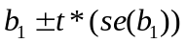
t* = 2.101 at df = 18
2.22 +/- 2.101(.2728)
2.22 +/- .5732
(1.65 < B₁<2.79)
We are 95% confident that the true slope of the regression line lies between 1.65 and 2.79.

9. What is the relationship between the F-statistic in the ANOVA table and the t-value for the slope coefficient?

The F-stat is the square of the t-stat.

10. Additional Extension Question:
Construct a 95% confidence interval for the mean value of y at x = x_{p}

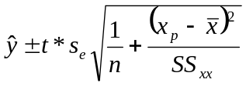= 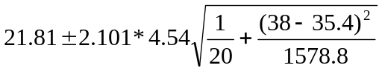
When given x-bar and SSxx

21.81 +/- 2.22

We are 95% confident that the predicted value of body fat percentage when waist size is 38” is between 19.5% to 24.03%

